ELECTRIC FOR EVERYONE

# Problem Statement

The challenge is to analyse vehicle registration data and explore the relationship between vehicle types and the uptake of EVs. Identify and analyse factors that may influence the adoption of electric vehicles.

# Solution/Idea

The solution for the analysis of the registration of the vehicles and even uptakes of EVs  
Since Fossil fuels are depleting and the cost price of fuel is a steady increase, we are in search of finding alternative fuels to drive vehicles. Thus, EV vehicles provide a solution for this. But there are various that hinder people from buying EV cars. We are providing our insights into why this is happening and help to resolve that hindrance. We have developed a strategy based analyse the charging infrastructure availability and prices of eve and consumer preference on geospatial data of the people in Melbourne having their types of cars based on the fuel type and EV intake. So that we can inform the government that to provide some subsidiaries to promote the EV buying in the particular increases also enhancing the infrastructure

## The Analysis

To start our journey, let's take a look at a map showcasing the distribution of EV ownership across different suburbs. As you can see, there's a clear variation in the concentration of EVs in different areas

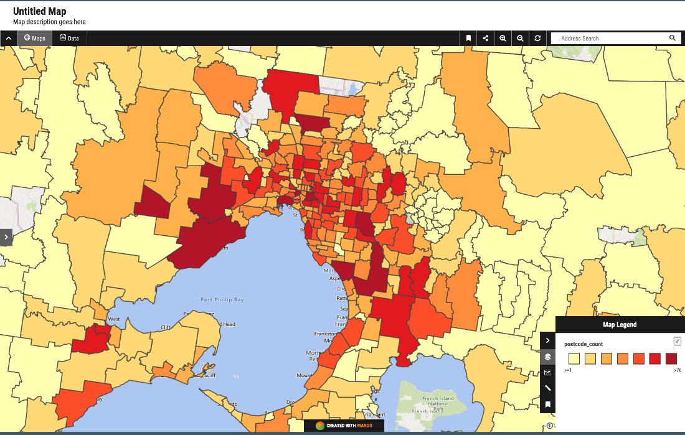

Figure Tiers of Suburb Levels

One crucial factor influencing EV ownership is income. Research consistently shows a direct correlation between higher income levels and a higher likelihood of owning an EV.

Suburbs with higher average incomes tend to have more EVs, which can be attributed to the higher upfront costs of EVs and associated infrastructure.

For example, Toorak has an average income of 98,000$ per year compared to Gannawarra with 44,000$. And from the data we can see the EV ownership in Toorak is a lot higher than the suburbs such as Gannawarra.

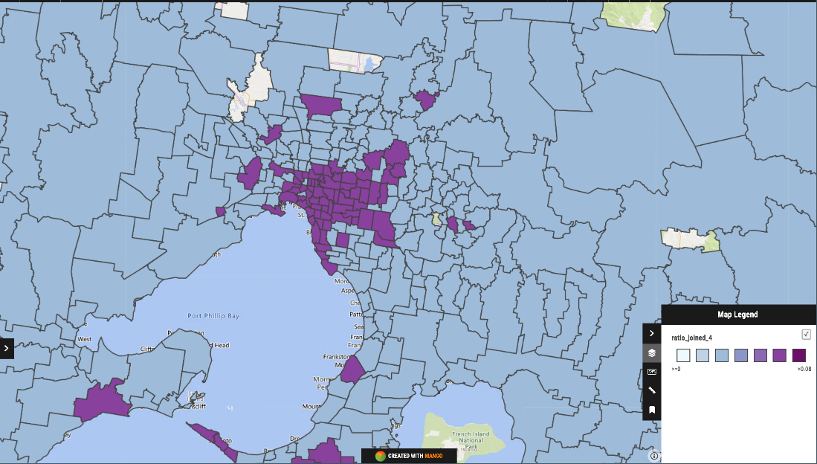

Figure 2 Tiers of Income Levels

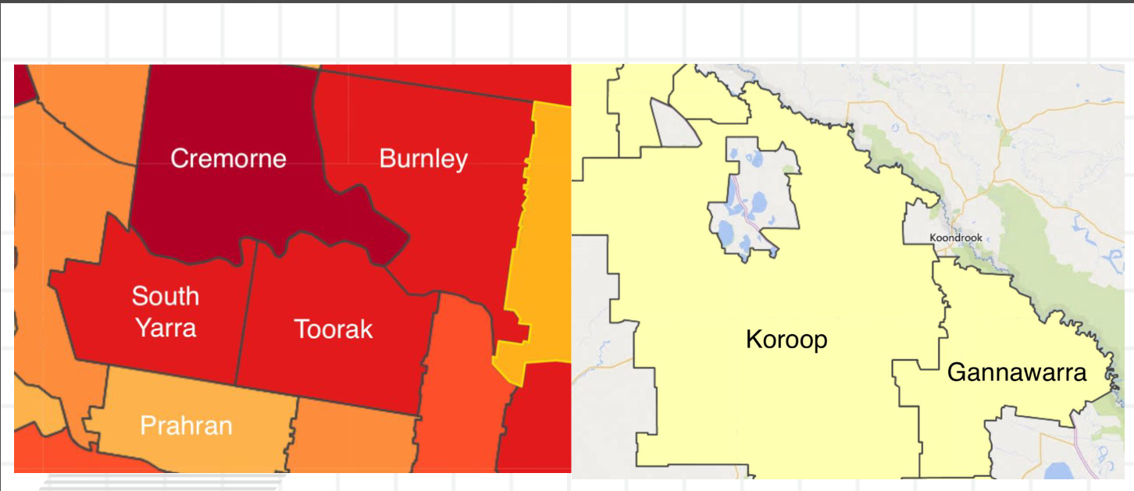

Figure 3 Tiers of Comparison of EV intake Levels

A key solution to tackle the affordability challenge is government incentives.

Countries like the Netherlands and Germany have embraced this idea, offering substantial incentives to promote EV adoption. This has led to a remarkable increase in EV ownership in these regions. Shifting our focus to our local context, we can observe a contrast. The Victorian government has not been providing enough support in terms of government incentives for EV ownership. Queensland by comparison provides twice as much in government incentives compared to Victoria. As a result of this, Victoria is only responsible for one of the top 10 cities for EV ownership in Australia.

As a result, EV ownership in Victoria lags behind other regions, despite the fact that EVs can contribute significantly to reducing emissions and improving air quality.

# Conclusion

In conclusion, the future of transportation is undoubtedly electric, with benefits for both the environment and our wallets.

However, the challenges of affordability and government incentives play a pivotal role in determining the pace of EV adoption.

As we move forward, it's essential for governments, communities, and stakeholders to collaborate in overcoming these barriers, making EVs accessible to a wider range of individuals and driving us towards a cleaner and more sustainable future.

# Dataset:

<https://hackerspace.govhack.org/challenges/explore_the_relationship_between_vehicle_types_and_the_uptake_of_evs>

<https://www.abs.gov.au/statistics/labour/earnings-and-working-conditions>

<https://discover.data.vic.gov.au/dataset/development-activity-monitor>

<https://www.abs.gov.au/statistics/labour/earnings-and-working-conditions/income-and-work-census/latest-release#data-downloads>

<https://www.aip.com.au/historical-ulp-and-diesel-tgp-data>